Solution 2:

interface dateInter
{
currentDate:Date;
disp():void;

}

class Car implements dateInter {
//field
currentDate:Date;
//constructor
constructor() {

}

//function
disp():void {

this.currentDate = new Date();
console.log("date is "+this.currentDate)
}
}
//create an object
var obj = new Car()

obj.disp()

Solution 3 and 4


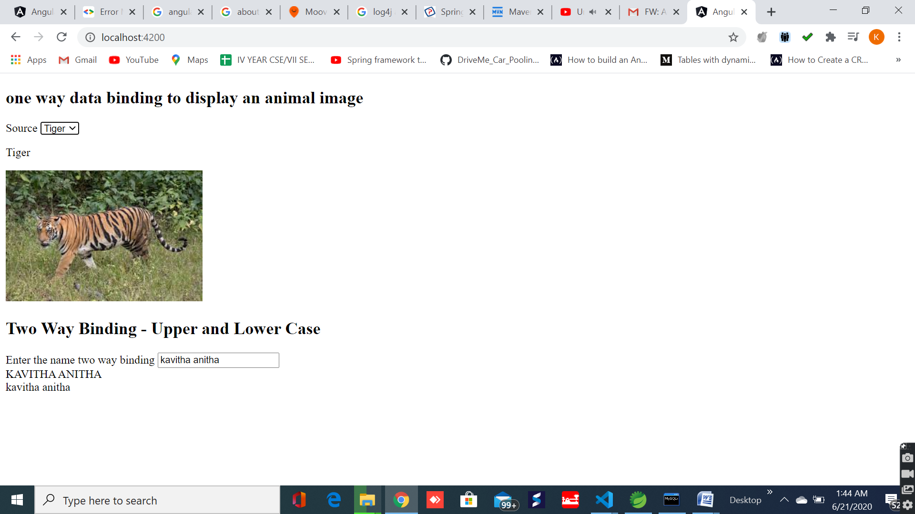

Solution 5: form
